June 22nd, 2008
Hi
Not that much to write about. We were getting very wet weather earlier in the week, though not as much as the US Midwest has been getting. Then for the last two days, it has been very hot, with the hot weather warning being issued.

I intended to swim for five days but because of the weather, only managed to get four. On the day I missed, I did a 25-minute row, the first row for a long time. For the swimming, I did 10 km for the week; not the most, which I think was 11 km in a week.
I have been having big problems with my computer. I cannot get any sound, all the little ‘Quick launch’ icons (bottom rhs of screen) disappeared, for certain commands I have to wait for up to a minute for a response and on one day my Norton security disappeared and I had to reinstall it.

In HK, a budget hotel suddenly closed without any notice and the guests were shoved out onto the street!! Though, to be fair to the hotel, they did suggest the guests could stay in a nearby street sleepers’ hostel!! The Lantau Cable Car, which was supposed to open again after damage caused by the storm last week, will now not open until further notice because of further mechanical problems. I noticed that in the letter for this week last year, it was also out of action!
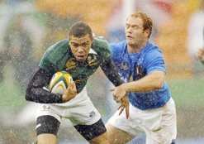
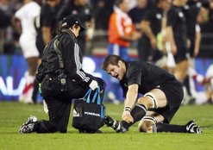
In Christchurch, the ABs convincingly beat England 44-12 in the second of their two Rugby tests. But several key NZ players suffered significant injuries, including the captain (picture) And in South Africa, a ‘new look’ Springbok team less than convincingly beat Italy 26-0. The first tri-nations match will be in two weeks, between NZ and SA.
Leonie, have a good holiday in Sicily.

That is it for now.

Cheers

